**Goal:** Review the existing NodeFlix product line and design a more robust and scalable solution.

**Personas:**

**GEORGE**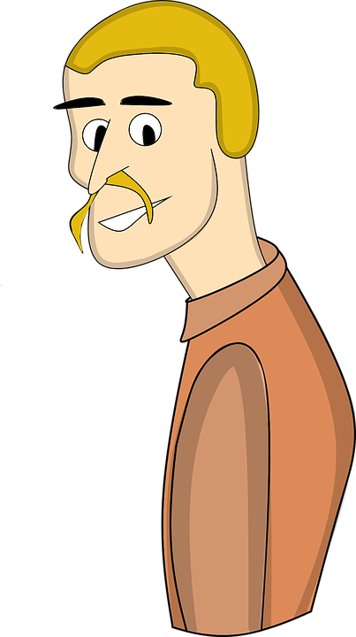

|  |  |
| --- | --- |
| **Age Range** | **40’s** |
| **Gender** | **Male** |
| **Location** | **California, OC** |
| **Computer Skill level** | **Novice** |

|  |  |  |  |  |
| --- | --- | --- | --- | --- |
| **Distinguishing Characteristics** | **Important Features** | **Non-important Features** | **Application Needs that can be met** | |
| **Laptop and Android** | **Watch newest series** | **No commercials** | **Recommended series on landing page** | |
| **Safari browser** | **War documentaries** | **Premium channels** | **Recommended documentaries on landing page** | |
| **New User** | **DVR** | **Pre-recorded sport events** | **DVR option available** | |

**SAM**

|  |  |
| --- | --- |
| **Age Range** | **20’s** |
| **Gender** | **Female** |
| **Location** | **New York, Uptown** |
| **Computer Skill level** | **Experienced** |

|  |  |  |  |  |
| --- | --- | --- | --- | --- |
| **Distinguishing Characteristics** | **Important Features** | **Non-important Features** | **Application Needs that can be met** | |
| **iPhone, always the latest model** | **Reality series** | **Sports streaming** | **Most watched reality series on landing page** | |
| **IE browser** | **Baking shows** | **News** | **Newest baking shows on landing page** | |
| **Existing User** | **DVR** | **Up to 4 streaming connections** | **DVR option available** | |

**BRIAN**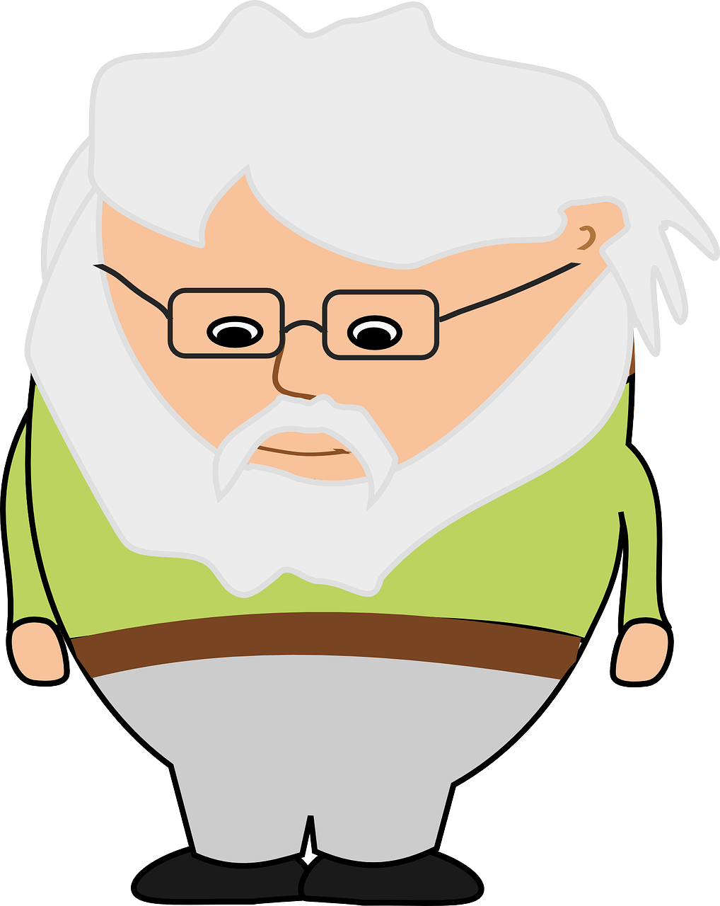

|  |  |
| --- | --- |
| **Age Range** | **80’s** |
| **Gender** | **Male** |
| **Location** | **Midwest, Suburban** |
| **Computer Skill level** | **None** |

|  |  |  |  |  |
| --- | --- | --- | --- | --- |
| **Distinguishing Characteristics** | **Important Features** | **Non-important Features** | **Application Needs that can be met** | |
| **Desktop** | **Limited commercials** | **No commercials** | **Ability to skip commercials** | |
| **IE browser, old version** | **Unlimited game shows** | **DVR** | **Most watched game shows on landing page** | |
| **New User** | **Unlimited old movies** | **Premium channels** | **Recommended movies on landing page** | |

**User Stories:**

UI/Designer Perspective stories (Source: Bohnet):

1. As a UI/Designer, I want the ability to search for listings.
2. As a UI/Designer, I want the top recommendations to be easily identified.
3. As a UI/Designer, I want search results to appear as entering the search request.
4. As a UI/Designer, I want autocomplete available for search queries.
5. As a UI/Designer, I want landing pages to be customizable.

User Perspective stories (Source: Bohnet):

1. As a user, I want to be able to watch pre-recorded shows.

2. As a user, I want to be able to upgrade my package online.

3, As a user, I want to be able to set a reminder for upcoming new shows.

4. As a user, I want to be able to skip commercials.

5, As a user, I want the option available to record shows.